APPLICATION FOR 2017 GA (PSI) STATE LEADERSHIP SEMINAR
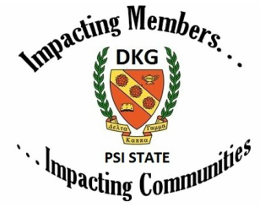
Date: June 2-4, 2017

Location: Hampton Inn and Suites
Macon, GA

Application Deadline:
May1, 2017

Prefer application be submitted electronically.
Name: (Ms., Miss, Mrs., Dr.)________________________________________________________________
Address:________________________________________________________________________________
Home Phone:____________________ Cell:______________________ Email:________________________
Chapter Name: ________________________District: ____________________
Currently working at: ___________________________ Job title: _________________________________
How many years have you been a member of DKG?
Initiation Date/Year
Have you attended a Psi State Leadership Seminar? If yes, indicate I or II.
When:
Where:
*If you completed Psi State Leadership Seminar I in 2016, you do not have to complete the remainder of the application. Simply sign your application and forward it to Dr. Patia C. Rountree.*
List your participation (include positions held & year) in Delta Kappa Gamma Society International or attach information.
Chapter level | State level | Regional level | International level

Briefly state what Delta Kappa Gamma Society International has meant to you.

List professional and community involvement and achievements:

Education: College/University Degree
______________________________________________________________________________________
______________________________________________________________________________________
______________________________________________________________________________________
Professional Experience (If retired, list previous employer):
A. Employer County Title
__________________________________________________________________________
__________________________________________________________________________
__________________________________________________________________________
B. Major Employment Responsibilities:
C. Years of Educational Experience:
What do you envision from attending this Leadership Seminar?

Complete the statement:
Leadership is

I agree that DKG may use photographs of me with or without my name for any lawful purpose, including but not limited to the
purposes of publicity, illustration, advertising and Web content.
Return to:
Dr. Patia C. Rountree
6303 Court Place
Statesboro, GA 30461
patiacrountree@gmail.com

______________________________________
Participant’s Signature

Cost for Seminar is $100.00. Do not send with application. Participants will be notified of acceptance and will, at that time, be requested to send the registration fee. Prefer application to be submitted electronically.

